This template is a supplement to the AP Recruit User Guide. Recruit Analysts may use this with the Department Chair, Search Committee Chair, and others in their department to create a draft of the recruitment plan prior to entering the information in AP Recruit. Note that data fields may change overtime. Please refer to the AP Recruit User Guide for the latest information; this is only a supplement and is not meant to replace the guide.

This serves as a general template for the colleges/schools/units and may be customized according to the unit’s business processes and needs.

Create a New Recruitment Plan

- The following basic information is required before entering the Search Information details.

Fields | Description
Recruitment Name | Give it a unique, descriptive name, something that matches your ad copy and also incorporates your unit's name. This is particularly helpful for the applicant who may be applying to more than one "Assistant Professor" position, e.g. Assistant Professor in Experimental Condensed Matter, Department of Physics
Description* | Add a description in the text field provided. The description appears to applicants on the apply page and the wording should be the same or similar to that used in all advertisements.  - Include the Equal Opportunity/Affirmative Action Employer tag line (EEO).  - Include UCR-specific information (refer to the Academic Hiring Toolkit)  - Return to edit this section to add the public URL, the unique web address for ads, postings, and links on other websites.  This field renders Markdown, which makes it possible to use bold, italics, headers, links, and other formatting elements. The description will be locked once the Search plan is approved.

- Accept applicants? Keep the default button selected, "Accept Online Applicants". This will give you the full functionality of Recruit. For information on "Diversity Survey Only" recruitments, refer to the AP Recruit User Guide.

- Click Create Recruitment Plan. The recruitment becomes a "Draft".

Checklist

AP Recruit provides a checklist to guide users on requirements.
- Expand the checklist to see what is missing.
  - Solid orange dots indicate when information is needed.
  - Green dots with checkmarks indicate when information is complete.
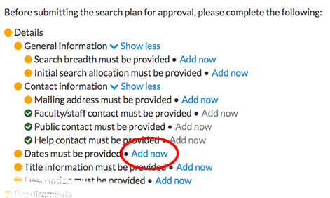

Recruitment Details

Details: General Information

Salary control #
This can be left blank.

Salary range

Rank/Step

Job location
The city and state where the hire will work

Search breadth
Is this an open/general search or a targeted/specialized search?

Initial search allocation
Is this position newly allocated or is it being re-listed from a previous academic year?

Approved search area
Area for which the FTE was approved (e.g. Medieval Studies, etc.)

Details: Contact Information

* Address
The mailing address that applicants may use
Faculty and staff contact name

Faculty and staff contact email

Public contact name

Public contact email

Help contact name

Information URL
A page with more details on the position, if one exists

Details: Description (this field will be locked after the search plan is approved)
[Enter the description of the recruitment. This should match your ad. In AP Recruit, this field accepts an unlimited amount of text (and may include links). When applicants apply to this recruitment, this description will display.]
IMPORTANT: Remember to check with your college/school/unit AP Recruit SME or EEAA for the most current information on Equal Employment Opportunity (EEO) mandatory tagline. If unsure, send an email to affirmativeaction@ucr.edu or aprecruit@ucr.edu. You can also refer to the Academic Hiring Toolkit.
In addition to the EEO tagline, the following two paragraphs must be included in the body of
the advertisement, but may be combined with other items. This applies to advertisements
placed in journals, on college, department, society or personal websites, as sent out to
departments at other universities, and the copy reproduced in AP Recruit.

- UCR is a world-class research university with an exceptionally diverse undergraduate
student body. Its mission is explicitly linked to providing routes to educational success
for underrepresented and first-generation college students. A commitment to this
mission is a preferred qualification.

- Advancement through the faculty ranks at the University of California is through a
series of structured, merit-based evaluations, occurring every 2-3 years, each of which
includes substantial peer input.

Paragraph (a) must be included under Preferred Qualifications. Refer to the PEVC & VPAP memo dated 3/20/15 and FAQs for more information.

Paragraph (b) may be adjusted to reflect the advancement process for the title series being advertised. It may be omitted when not applicable to the search such as for temporary lecturer positions.

Details: Dates
There are 2 options: Open/Close/Final (OCF) and Initial Review Date (IRD). Note: The selected option cannot be changed once the recruitment is published.
Option 1: OCF refers to a one-time search that will complete when the vacant spot is successfully filled.
Open Date: [This is the anticipated date when applicants can begin applying. The recruitment will need approvals and the recruitment will then be published.] -Click here to enter date-
Close Date: [The date that no new applications will be accepted.] -Click here to enter date-
Final Date: [This is the last date for existing applicants to modify their applications. Match your close date if you don’t want to use this optional grace period.] -Click here to enter date-
Option 2: IRD refers to a long-running search in which pools of applicants are collected and evaluated separately at different times.
Open Date: [This is the anticipated date when applicants can begin applying. The recruitment will need approvals and the recruitment will then be published.] -Click here to enter date-
Initial Review Date: [This marks the closing of the first pool of applicants. Once the recruitment is posted in AP Recruit, the IRD cannot be changed. Please allow a minimum of 30 days after the Open Date] -Click here to enter date-
Review Date: [After the Initial Review Date has passed and if the initial applicant pool does not yield a qualified candidate, you may update the recruitment to establish more review dates. See: Specifying Additional Review Dates, AP Recruit User Guide, Pages 8-9.] -Click here to enter date-
Private Date (checkbox): [Check for an internal review date, not advertised to applicants.]
-Click here to enter date-
Final Date: [This is the last date when applicants can apply. If you add an additional review date that is after the final date, the final date automatically moves forward to accommodate it.] -Click here to enter date-

Details: Title Information: Enter the Title Code. If this is a multi-level recruitment, click on “Make this recruitment multi-level”. An example of a multi-level recruitment is a recruitment for an Assistant Professor and Associate/Full Professor.

Requirements: References
You may choose to have your applicants provide self-solicited reference letters OR reference contact information with their application OR nothing at all.
None – this recruitment does not require references
Only contact information – only ask for reference email and address - letters will be requested by the department as needed
Letters of recommendation – allow references to login and provide their letters when requested by the applicant. Minimum: Maximum:

IMPORTANT: Reference requirements will be locked after the first applicant applies. You may add optional documents if you need to collect additional data from applicants. You must notify all applicants that additional documents are being requested, if applicable.

Show References To: This is a drop-down menu in AP Recruit. You can select to restrict reference viewing to certain members of the search committee

Requirements: Documents
Define the required or optional documents to be provided by the applicants. The applicants will see any description you provide.

IMPORTANT: The document requirements will lock after the first applicant applies. You will still be able to add optional documents to collect additional information from applicants, but you will not be able to require new documents.

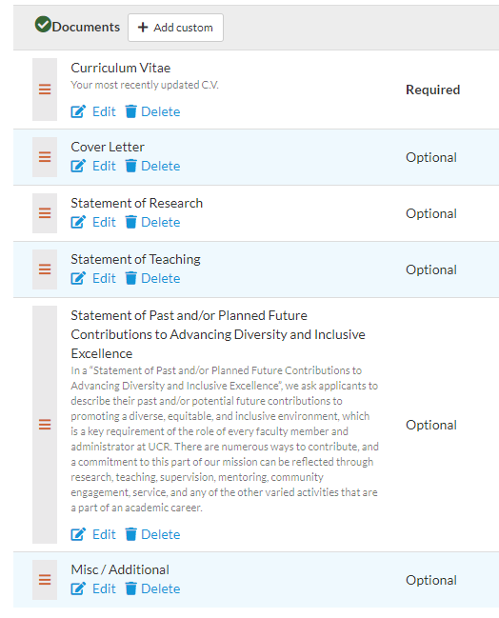
Diversity:
[For questions regarding this section, contact EEAA at affirmativeaction@ucr.edu.]

- Affirmative Action Goals [Identify the affirmative action goal for the title series by indicating which groups are underutilized on the campus for the specific job grouping.]
-Click here to enter text-

Advertisements:
[For questions regarding this section, contact EEAA at affirmativeaction@ucr.edu.]

- Planned Search & Recruitment Efforts: State what actions will be undertaken by the search committee to meet the affirmative action goals for the title series in order to achieve a broad and inclusive pool with respect to gender and race/ethnicity. If you do not know what to put here, work with your committee chair or contact EEAA.
-Click here to enter text-

- Actual Search & Recruitment Efforts: This is to be completed after the search and must include the actions completed by the search committee.

- Ad Documents: Upload copies of all advertisements that will be posted

- HERC Category: Select which category and area of expertise best fits the recruitment from the list of choices. This is a drop-down menu in AP Recruit.

- Ad Sources: List the sources/venues where your recruitment will be advertised
-Click here to enter text-

- Evidence of Advertisements: Upload proofs of advertisements

Qualifications:
[If you are unsure what to put in this section, contact the Department Chair or EEAA at affirmativeaction@ucr.edu.]

- Basic Qualifications: State the *minimum* qualifications required to be considered an applicant for the position. These qualifications must be met at the time of application.
-Click here to enter text-

- Additional Qualifications: State other qualifications *required* for the position. These qualifications must be met by the start date of the position.
-Click here to enter text-

- Preferred Qualifications: State other preferred, but *not required*, qualifications for the position. Include the following: ”UCR is a world-class research university with an exceptionally diverse undergraduate student body. Its mission is explicitly linked to providing routes to educational success for underrepresented and first-generation college students. A commitment to this mission is a preferred qualification.” This may be adjusted to reflect the advancement process for the title series being advertised. It may be omitted when not applicable to the search such as for temporary lecturer positions.
-Click here to enter text-

Selection Process
[If you are unsure what to put in this section, contact the Department Chair or EEAA at affirmativeaction@ucr.edu].

- Selection Criteria: Provide a detailed description of the selection criteria to be used in evaluating candidates in priority order.
-Click here to enter text-

- Selection Plan: State how the search committee will evaluate the applicants and select the shortlist and finalist (screening process, interview procedures, role of the search committee, etc.)
-Click here to enter text-

- Specializations: Enter all areas that applicants may pick as their specialization. Reviewers will be able to find applicants by their specializations.

Committee [Assign committee roles per recruitment]

Core Committee Members: Enter the roles and the names of the Search Committee Members that will be named on the Search Plan.
Committee Chair: -Click her to enter name-
Editor (Faculty): -Click here to enter name-
[At UCR, this is assigned to the AACO or Affirmative Action Compliance Officer]
Reviewer: -Click here to enter names-
Additional Access: Enter the roles and the names of the Additional reviewers who are not named on the Search Plan. This may be added later.
Additional Chair: -Click here to enter name-
Additional Editor: -Click here to enter name-
Additional Reviewer: -Click here to enter names-

Documentation: Recruit Analysts can archive and retrieve various materials associated with the recruitment in this section of AP Recruit. Follow University and departmental best practices and policies when uploading information under this section.

Disposition Reasons: Contact EEAA at affirmativeaction@ucr.edu if you have questions. To discuss adding a custom disposition reason contact APO at aprecruit@ucr.edu. Refer to the Applicant Management User Guide for more information on how to assign disposition reasons to applicants.

Thank you for using the AP Recruit system. If you have any questions, please contact your College/School/Unit Recruit Analyst (https://academicpersonnel.ucr.edu/aprecruit-contacts) or the AP Recruit support team at aprecruit@ucr.edu.

